SIMATS ENGINEERING ASSESSMENT TOOL 3

COURSE CODE: CSA14 COURSE NAME: Compiler Design

COURSE OUTCOME COVERED

CO4: Examine intermediate code generation techniques to enhance code optimization (BL4)

Assessment Tool Weightage: 10%

QUESTIONS: Total Marks:50

Code of Conduct:

I Hemalatha.C (192524475) certify that this submission is my original work and that I have adhered to the guidelines specified for this assessment.
I understand that any violation of academic integrity rules will result in disciplinary action.

Signature of the student:Hemalatha.C

Annexure A

CONCEPT MAPPING

1.Intermediate Language and Declarations

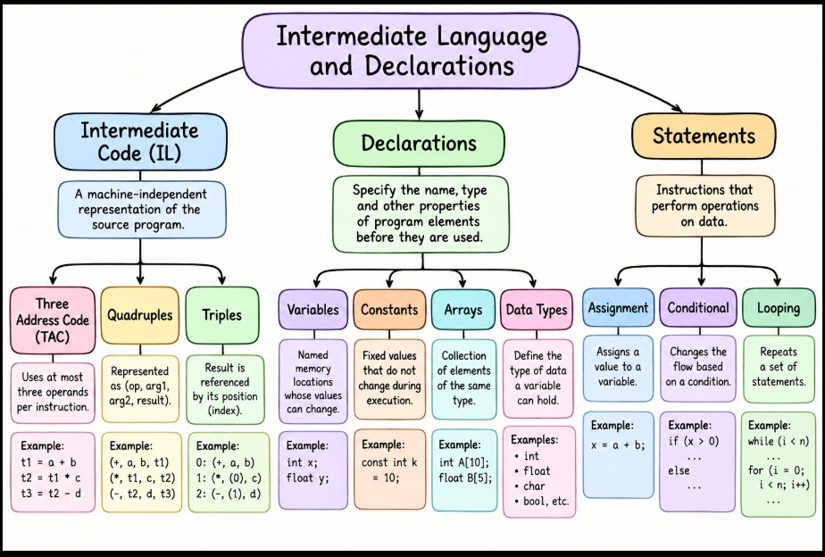

2.Assignment Statements and Boolean Expressions

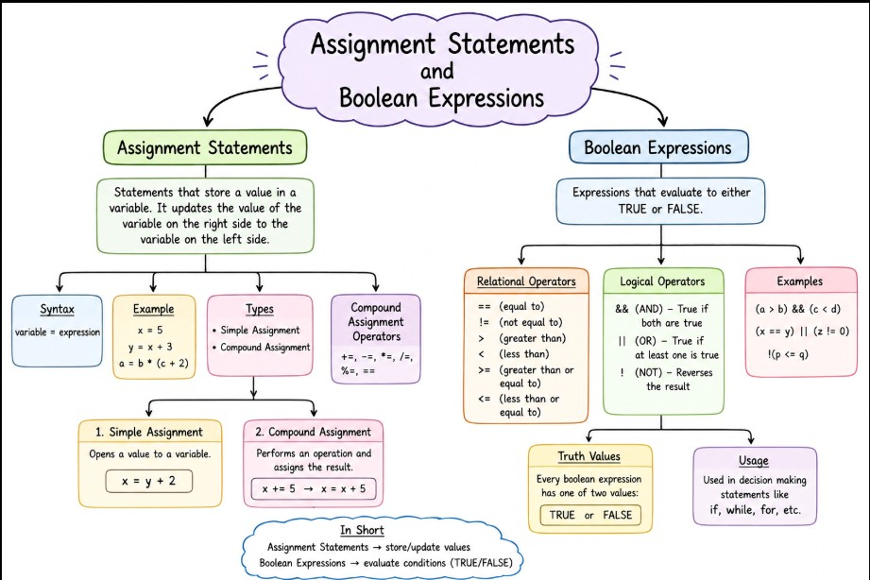

3.Case Statements and Backpatching

